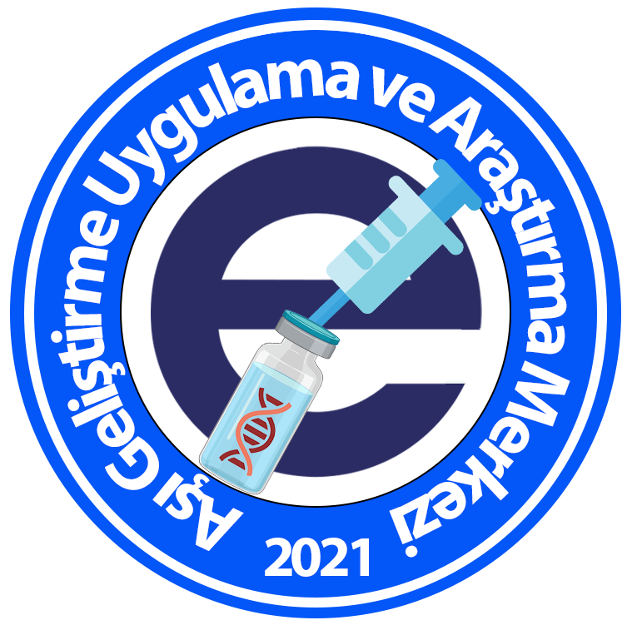 | Ege University  Vaccine Development, Application and Research Center Internship Application Form

Name surname
Phone
E-mail
Date of birth
Place of birth
Address
University
Faculty
Department/Department
Which class (3 or 4)
Formal (mandatory)/Voluntary
Between which dates (1 month)
Grade average

Internship application must be made between May, 1st-31st.
Curriculum vitae must be attached to the application form.

